structure and instructions:

1.

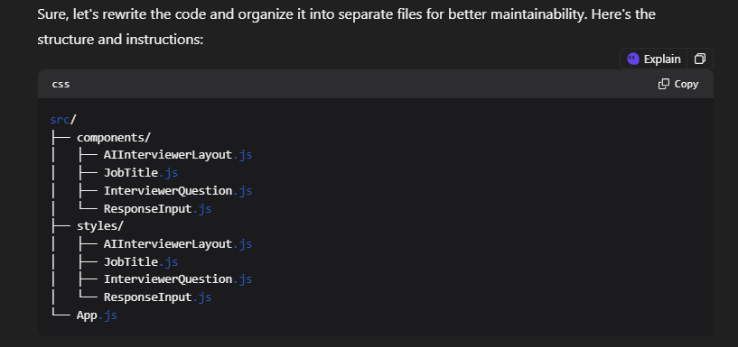

2. 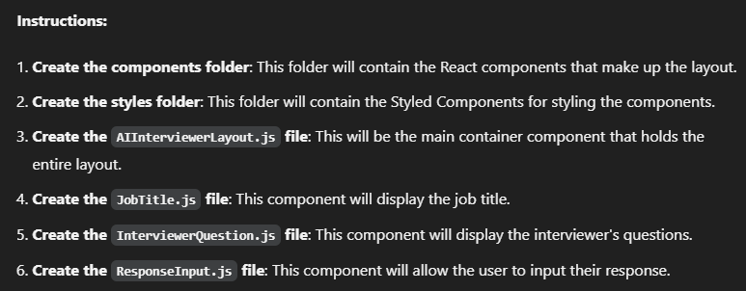

3.

Here's the code for each file:

AIInterviewerLayout.js

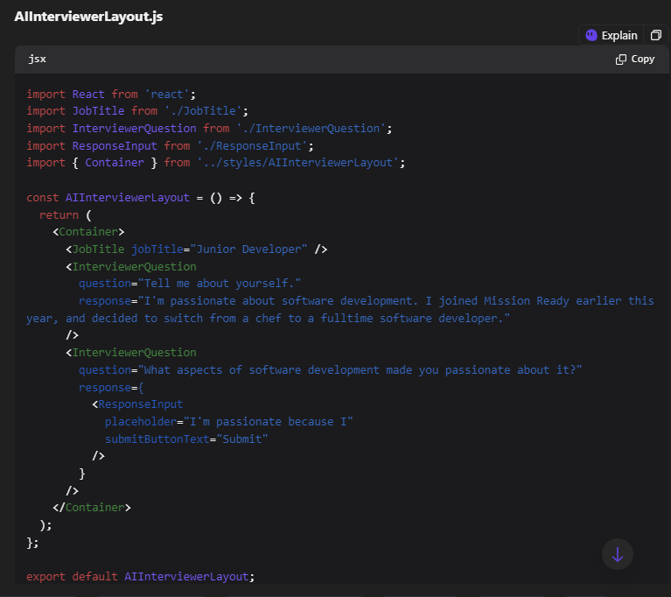

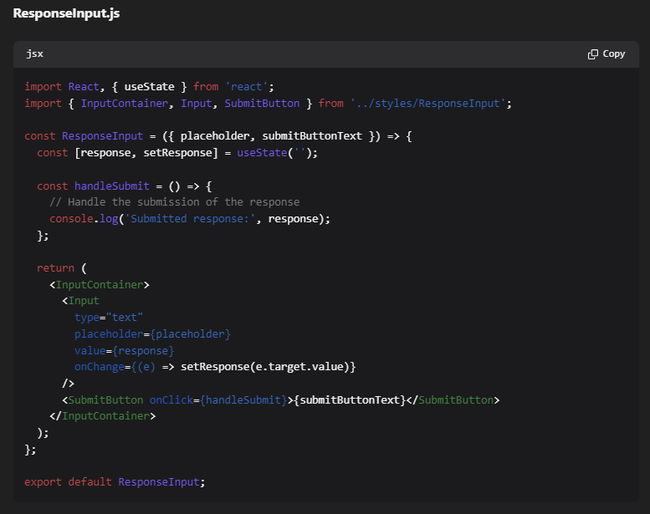

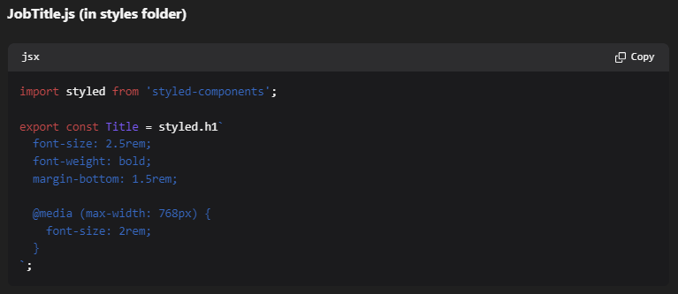

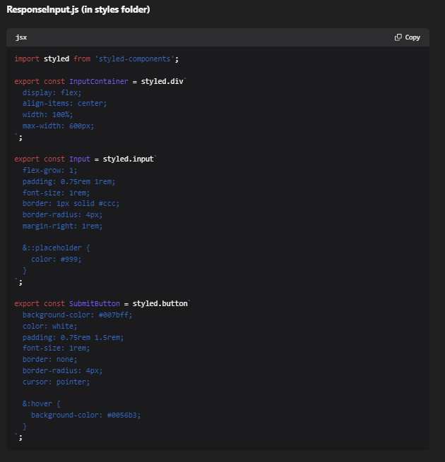



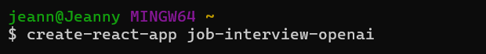

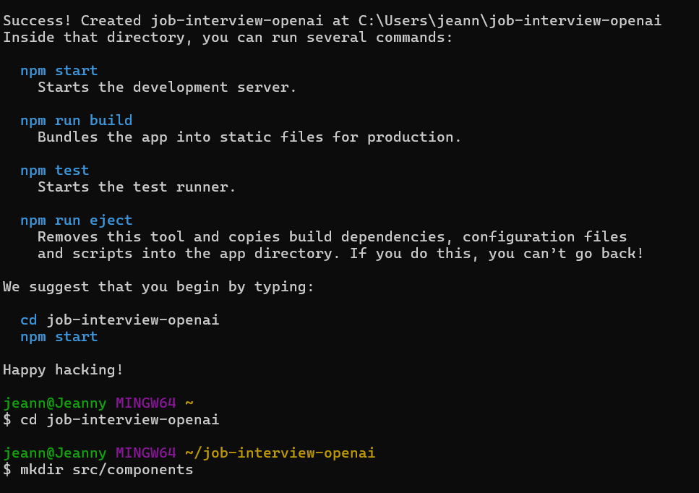

Example Folder:

mkdir src/components

touch src/components AIInterviewerLayout.js

touch src/components JobTitle.js

touch src/components InterviewerQuestion.js

touch src/components ResponseInput.js

the application is unable to resolve the 'styled-components' dependency in the specified file paths. This is likely due to a configuration or setup issue in the project.



